MINI PROJECT (2020-21)

NewsAPI

MID-TERM REPORT



Institute of Engineering & Technology

Submitted by-

Tanya Goyal

(181500754)

Siddharth Rai

(181500709)

Mansi Verma

(181500372)

***Supervised By: -***

**Mr. Mandeep Singh**

Technical Trainer

Department of Computer Engineering & Applications

Contents

|  |  |
| --- | --- |
| **Abstract** | **3** |
| **1. Introduction** | **4** |
| 1.1 General Introduction to the topic | **4** |
| 1.2 Area of Computer Science | **5** |
| 1.3 Hardware and Software Requirements | **6** |
| **2. Problem definition** | **7** |
| **3. Objectives** | **8** |
| 4**. Implementation Details** | **11** |
| **5. Progress till Date & The Remaining work** | **11** |
| **6. Some Screenshots** | **12** |
| **7. References** | **13** |

### **Abstract**

In this we will build a News website because Now-a-days we live in age of Information Communication and Technology (ICT). We can’t think a single moment without technology. From morning to night, we need help of the technology as now world totally relays upon the electronic media to its every day adventure. People have no time to be updated through newspaper or watching or listening the news in the television or radios. People need to be updated on daily basis in this competitive world. This is the revolutionary time of computer technology. Most of the works depends on web application. For this reason, anytime, anywhere, anyone can access website with Internet at low cost and we can find our expect-able and most update information on news website. At present information is one the most valuable resource of the current world or we can say that information is a weapon to us. In our project work, an attempt has been made to develop a News or Information based website. We develop this project that helps the people and make them aware so that they can know any news at any time and anywhere.

A real expert system is needed with much simpler and less sophisticated manner. “Inclick News” is a service introduced to meet the above requirement and to make the people updated about the news, views, reviews, breaking news and latest headlines in different fields . This news portal is targeted towards the growing news agencies and the other organization which are related to the field of media.

**INTRODUCTION**

* 1. **General Introduction to the topic**

Today, majority of people are busy in doing their work, no body have time to watch news on television or radios, so here is a gift to all people to get updated with world and to know that what is happening in the world.

As it is cost-effective and smart way to stay updated. More Choices -You can read a vast number of articles/ news/editorials at a time. 24/7 Updates — Online news are updated instantly and thus, provide your real-time updates.

The “InClick” Online News Portal has been developed to override the problems prevailing in the practicing manual system. This software is supported to eliminate and in some cases reduce the hardships faced by existing system.

The application is reduced as much as possible to avoid errors while entering the data. Thus by this all it proves it is user-friendly.Online News Portal, as described above, can lead to error free, secure,reliable and fast management system.

Every organization, whether big or small, has challenges to overcome and managing the information of News Category, News Sports, News Technology, News Health, News Business, News Entertainment, News Science. Every Online News Portal has different needs, therefore we have taken help of API’s to fetch different categories of News. It help us to provide us Latest News.

**About Inclick:**

We need help of the technology as now world totally relays upon the electronic media to its every day adventure. People have no time to be updated through newspaper or

watching or listening the news in the television or radios. So, we have made an online web application through which People can access online news anywhere, anytime. People need to be updated on daily basis in this competitive world. Inclick is just an online news web application.For this reason, anytime, anywhere, anyone can access website with Internet at low cost and we can find our expectable and most update information on news website. At present information is one the most valuable resource of the current world or we can say that information is a weapon to us. In our project work, an attempt has been made to develop a News or Information based website.

**How Inclick Works: -**

In days world we people hardly spend time on our self but we all wants to be updated so we bring this news site called “Inclick” you don’t have to download it. It can be easily available on any browser and can be access at any device. We made your work a lot easier.In Inclick news, News are divided into several categories like Sports News, Science News, Entertainment News, Business News, Technology News, Health News.

So let’s say if you want to know Sports News, you just have to chose from the category i.e from Sports category and you’ll get the news of Sports. It just a piece of cake. You don’t require to install it at any device. It is much simpler and less sophisticated manner. This news portal is targeted towards the growing news

agencies and the other organization which are related to the field of media.

**1.3 Hardware Requirements**

• Memory [4GB RAM (or higher)]

• Intel core i3 64-bit Processor (or higher)

**1.3 Software requirements**

• Technology Implementation :

Front-end : JavaScript, HTML , CSS, Bootstrap

Back-end : PHP, MySQL

• Web Browser : Chrome, Microsoft Edge, Opera mini etc

**Objective**

The main objective of the project on InClick news is to manage the details of News, News Category , Latest News, Sports News, Technology News etc. It is a web application for Online News Paper website that can aware the people and it is use to provide the daily news. Anytime, anywhere, anyone can know about the news or information by internet at low cost. It doesn’t require any installation you just required an internet through which you can see news at any device at any browser.

**Implementation**

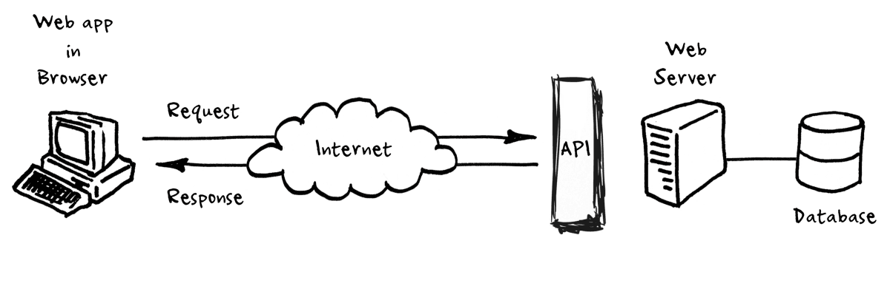

**Part1:** Publishing news on webpage using News API.

With the help News API (Application Programming Interface), we have published news with various categories.

News API is a simple HTTP REST API for searching and retrieving live news articles from all over the web. Using this, one can fetch the top stories running on any news website or can search top news on a specific topic (or keyword).

**Part2:**  Introducing SEARCH for easier access to information.

• Search lets you find any short, recent or old, by simply typing in a keyword in the search box.  
 • Looking for a particular short, or shorts related to a past/ongoing topic? We got it all covered.  
 • Our search bot also suggests topics related to your search query, so you stay informed end-to-end.

**Part3:** Creating User’s -end

* It enables the user to login or signup .
* User can save their favourite news.

**Progress**

1. ) Part 1 is completed

**Functionalities provided by Online News Portal as follows:**

* Provides the searching facilities based on various factors. Such as Latest News, Sports News, Health News etc.
* Easy to understand by user.
* It tracks all the information of news category with the help of News API.
* Manages the information of News.
* Shows the information and description of News, Latest News.
* It help us to give latest News.
* It fetches business News with the help of business API.
* It fetches Health News with the help of Health API.
* It fetches Entertainment news with the help of Entertainment API.
* It fetches Science news with the help of Science API.
* It has menu button through which user can select category of respective News.
* To increase efficiency of managing the News, News category.

1. ) Part 2 is to be completed

* We can make it more reliable by providing it back-end.
* Because with the help of back-end user can save news as an bookmark.
* With back-end News Portal become more user friendly.

**SCREENSHOTS**

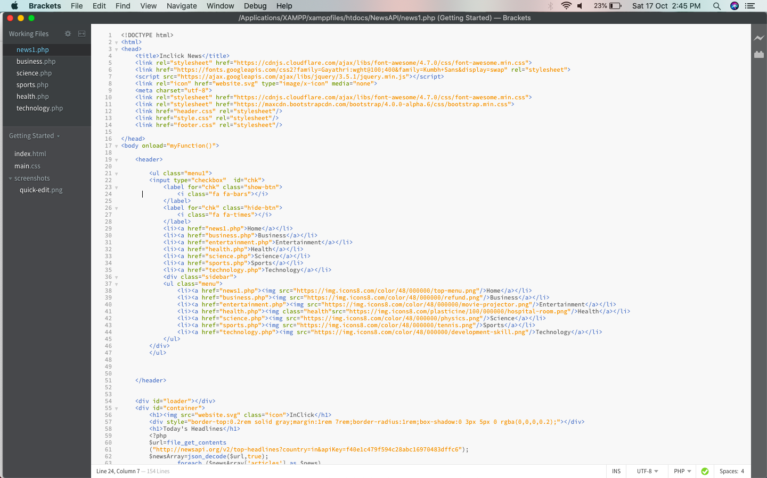

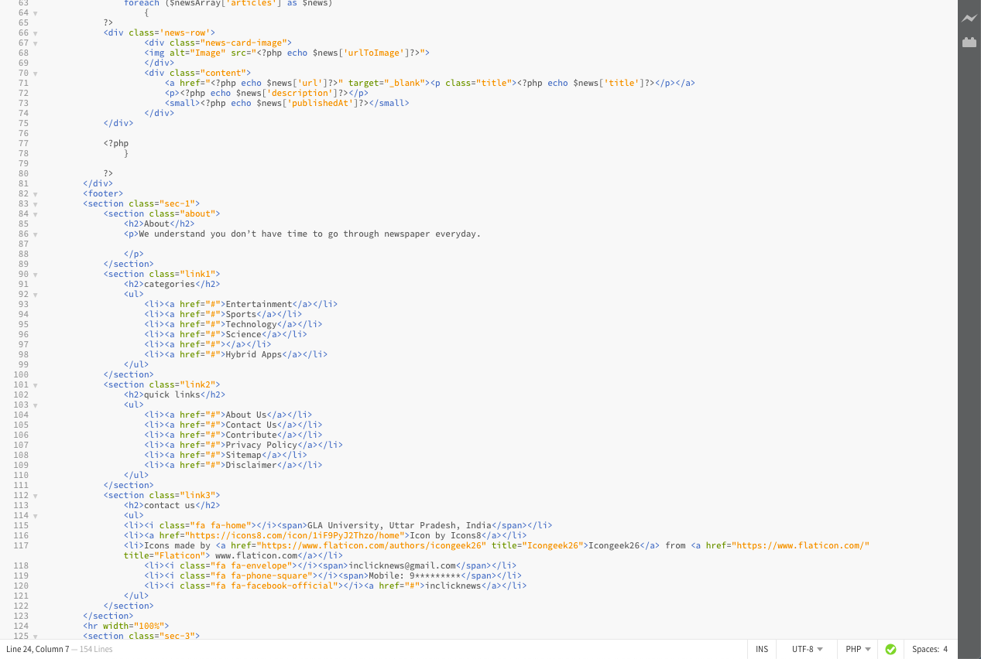

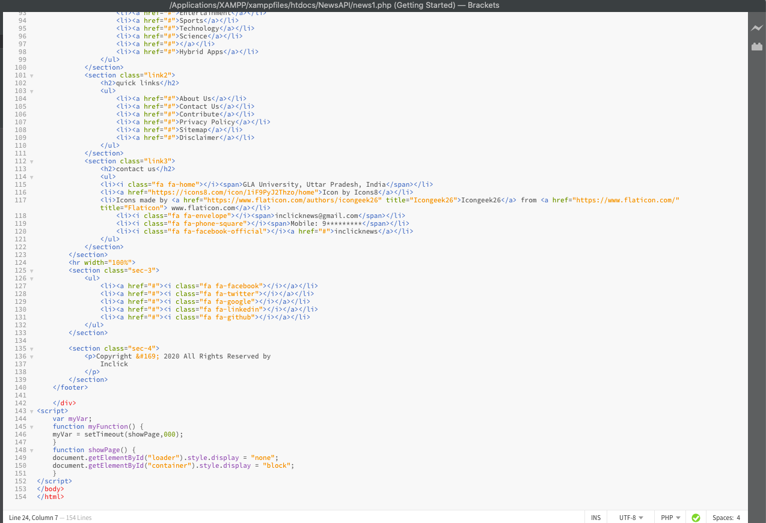

(Business)

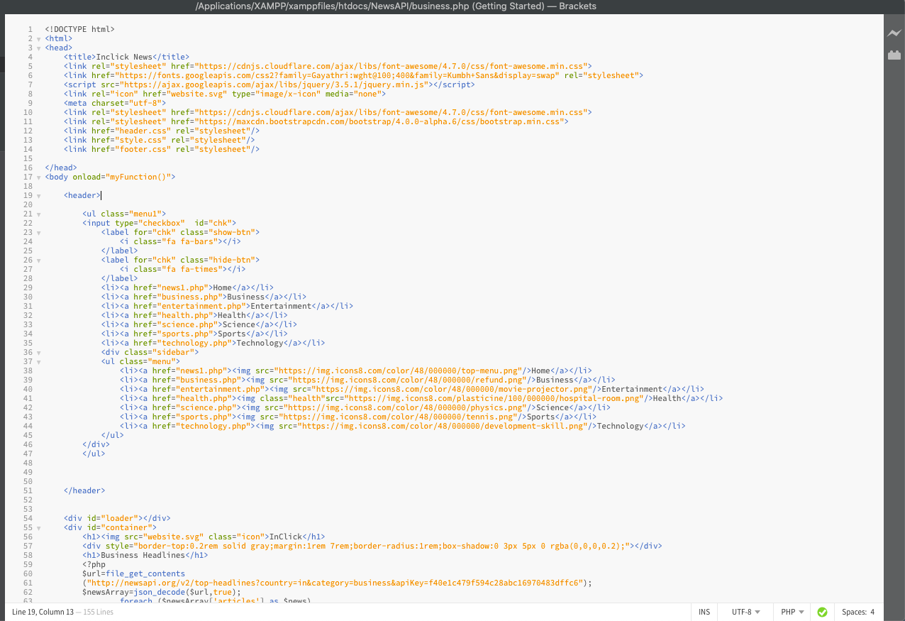

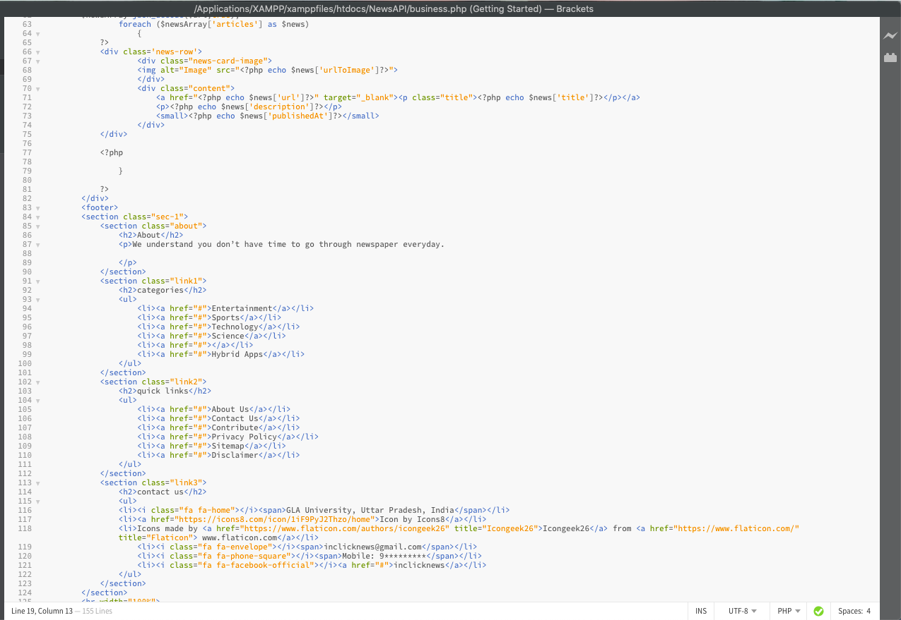

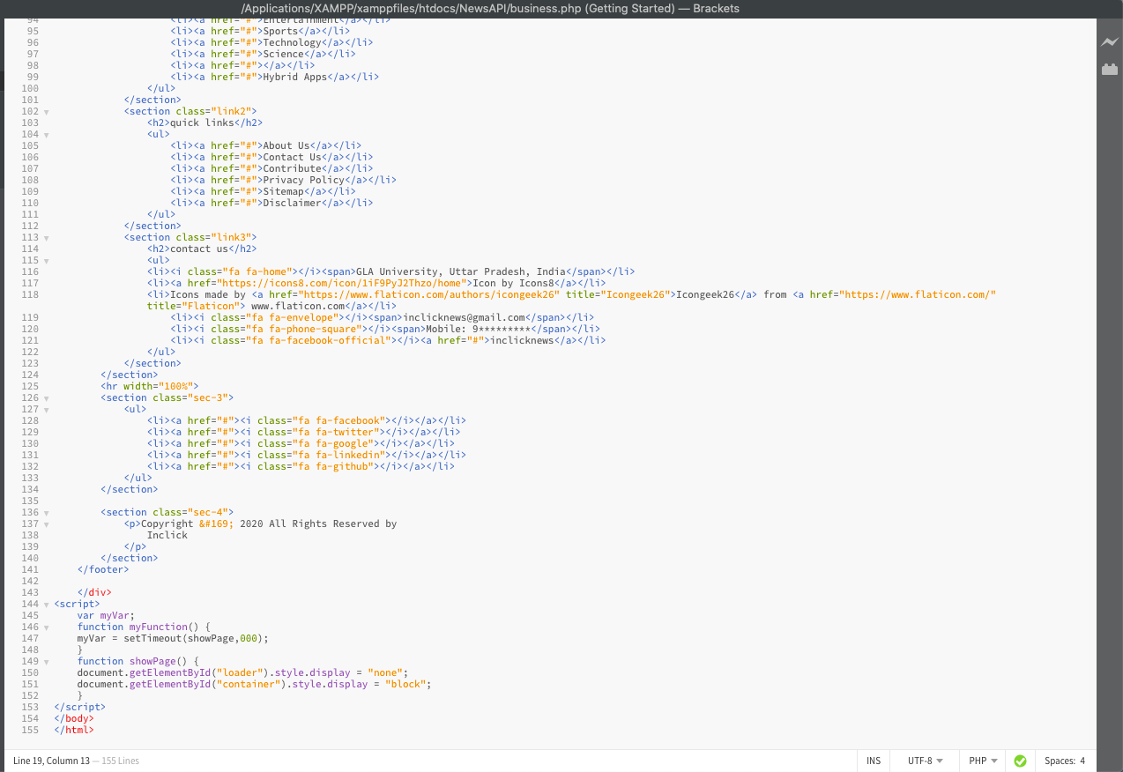

(Entertainment)

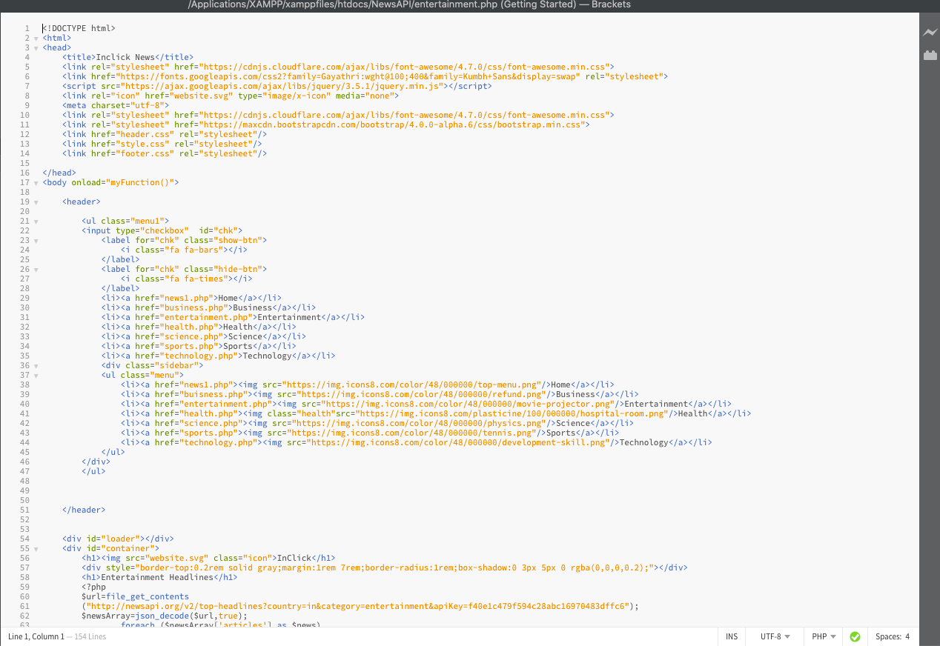

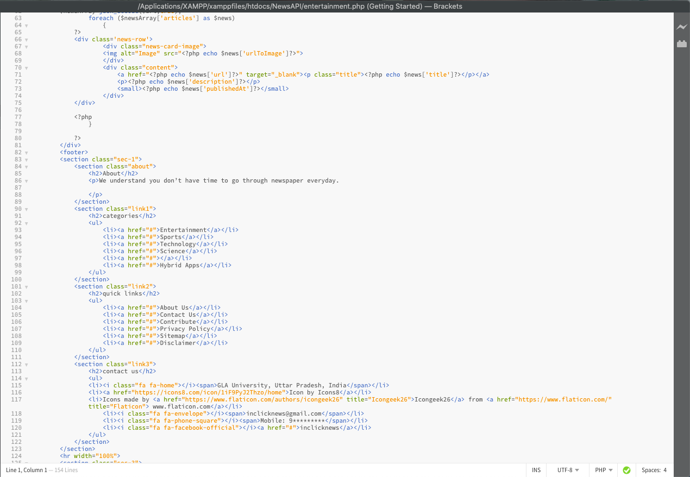

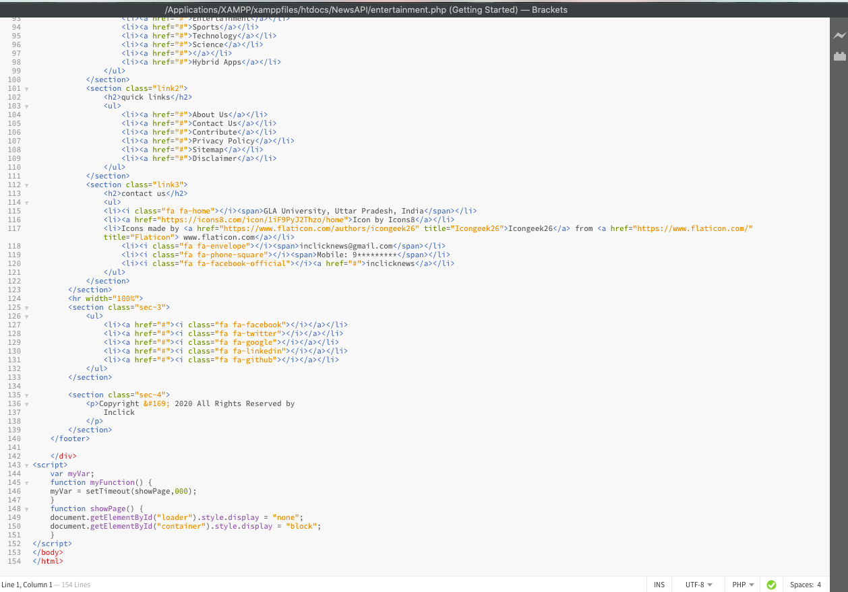

(Health)

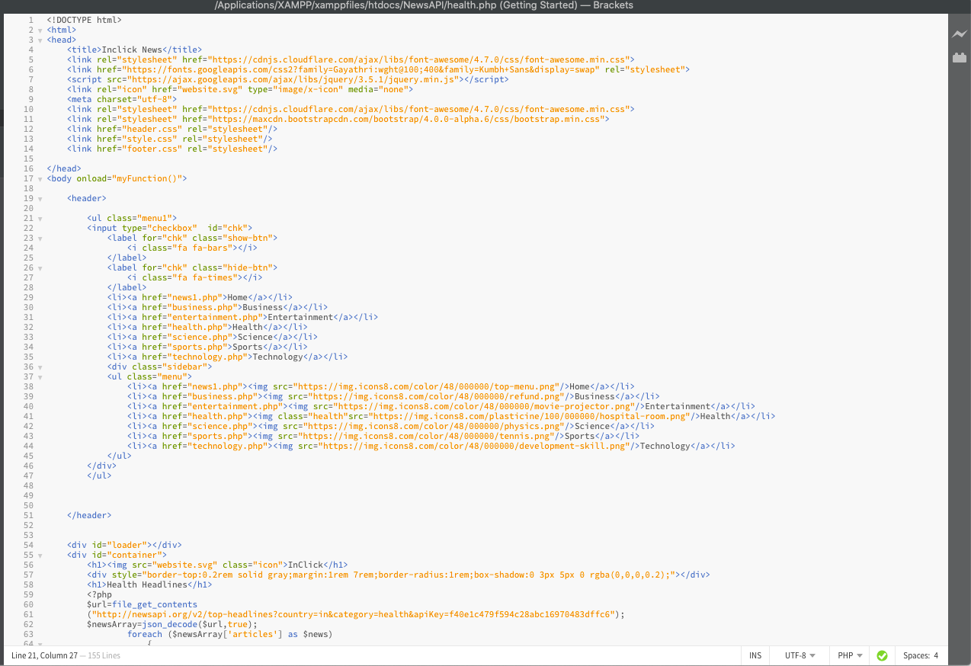

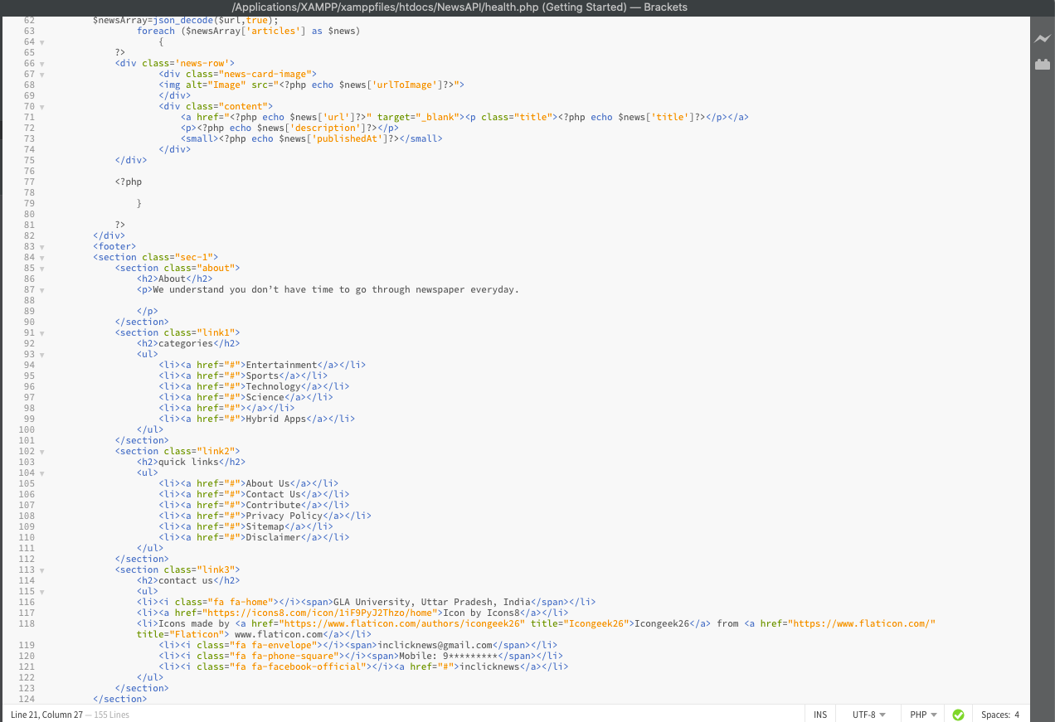

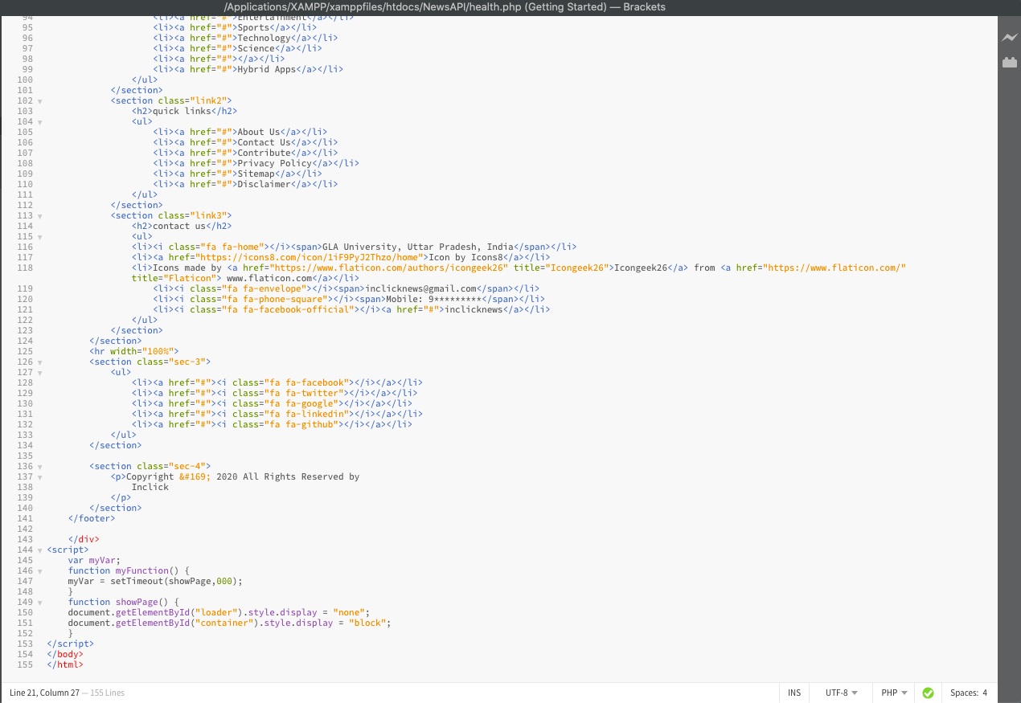

(Science)

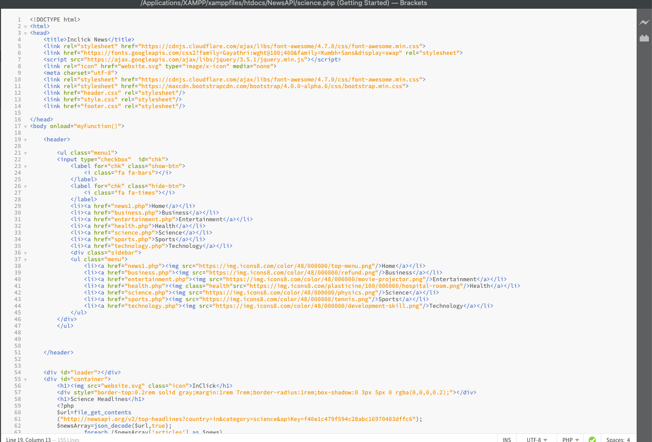

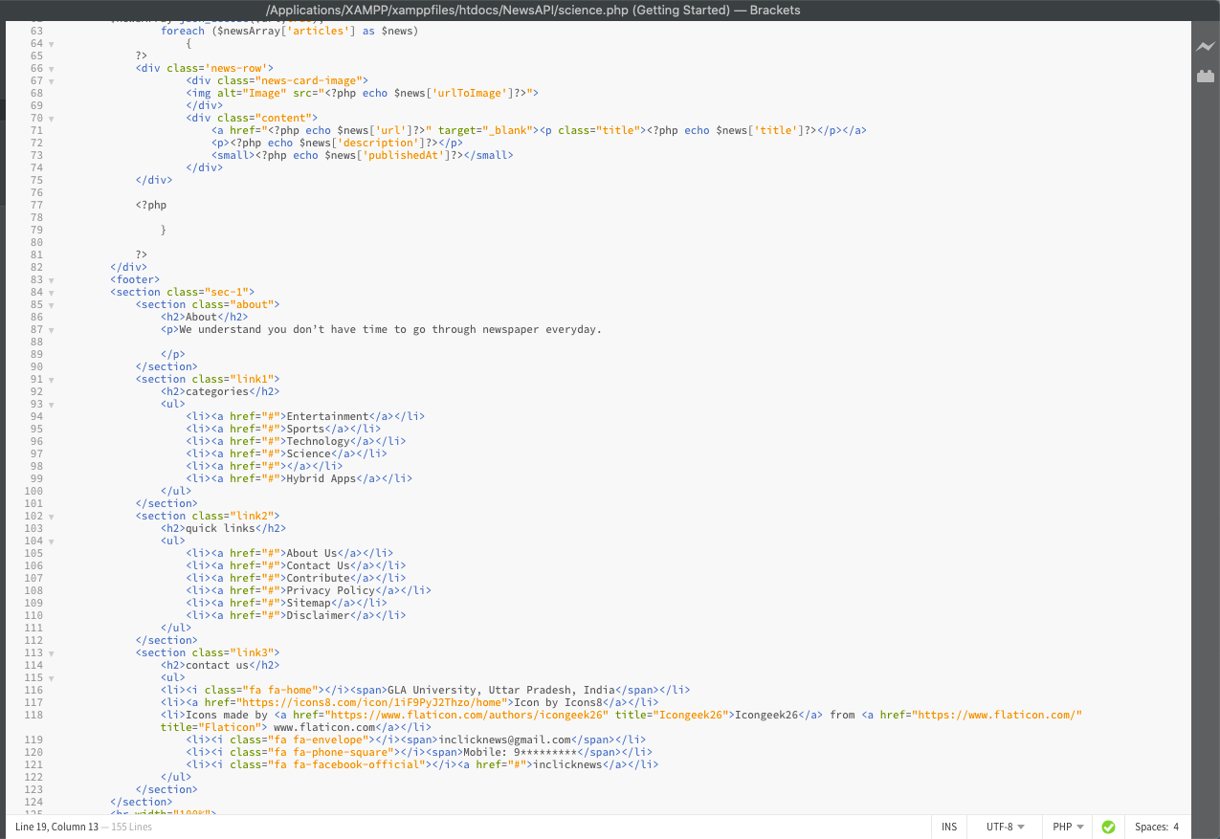

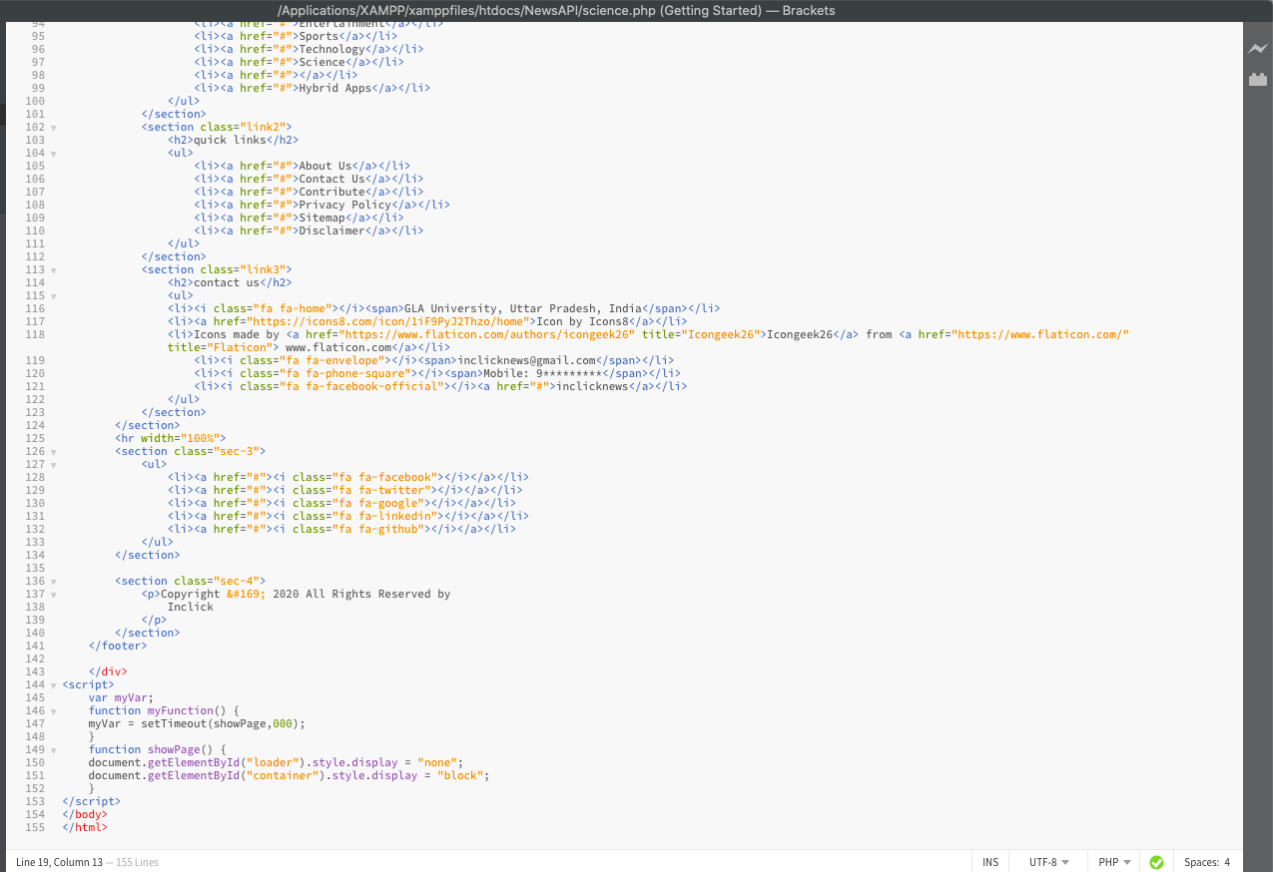

(Sports)

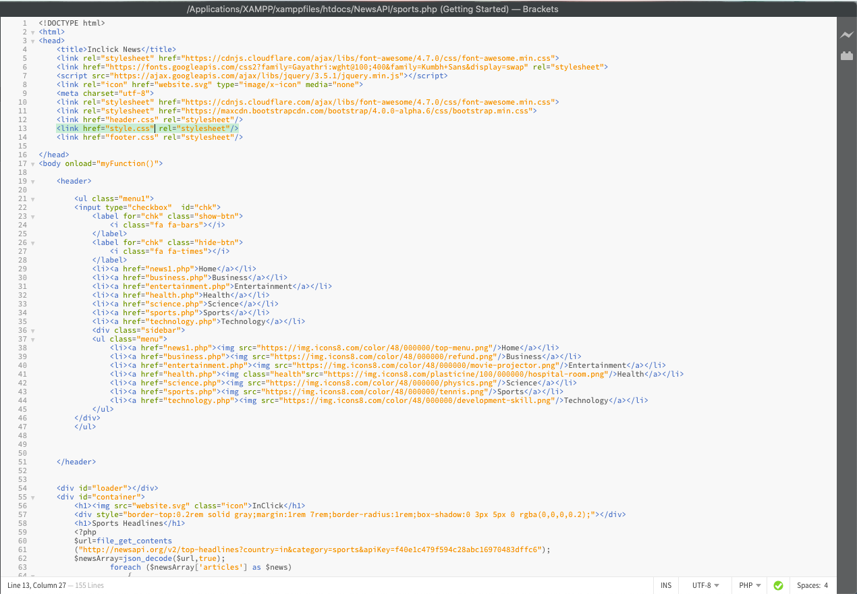

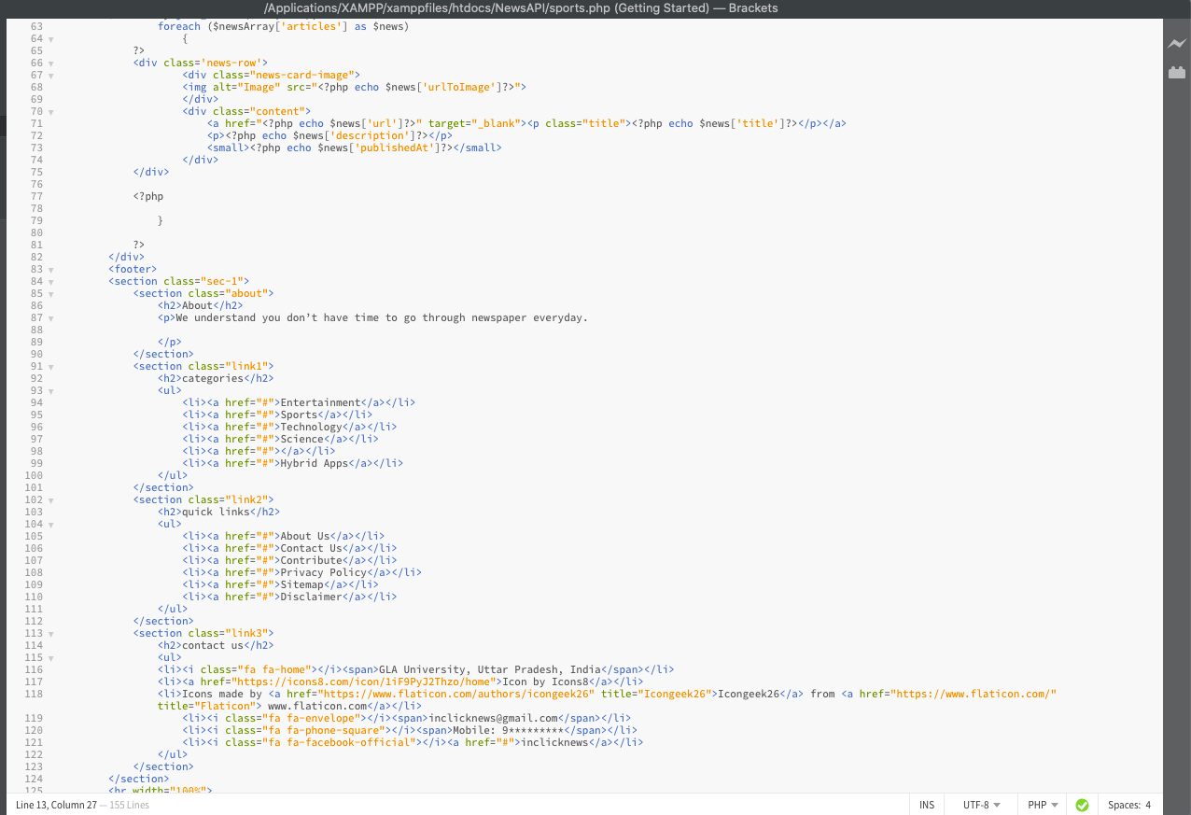

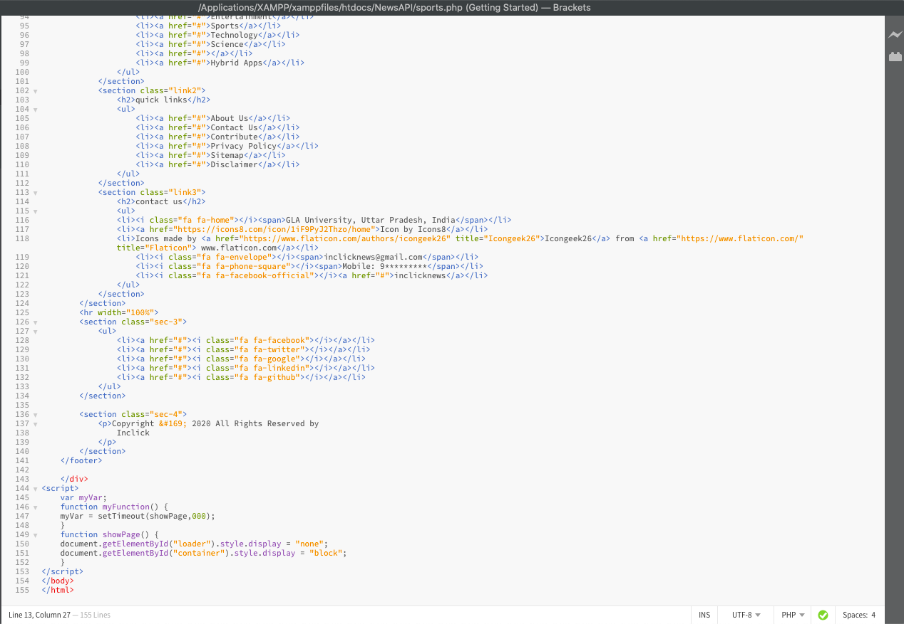

(Technology)

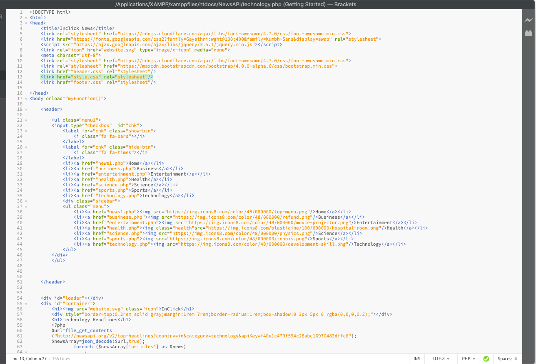

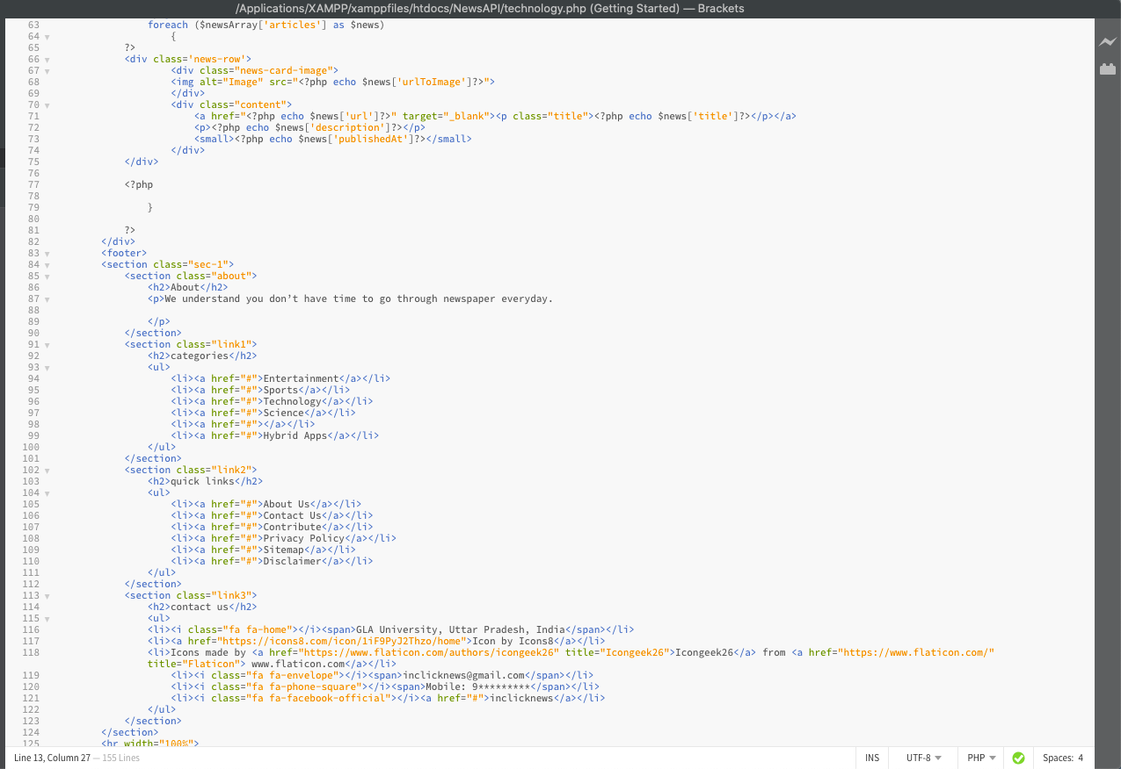

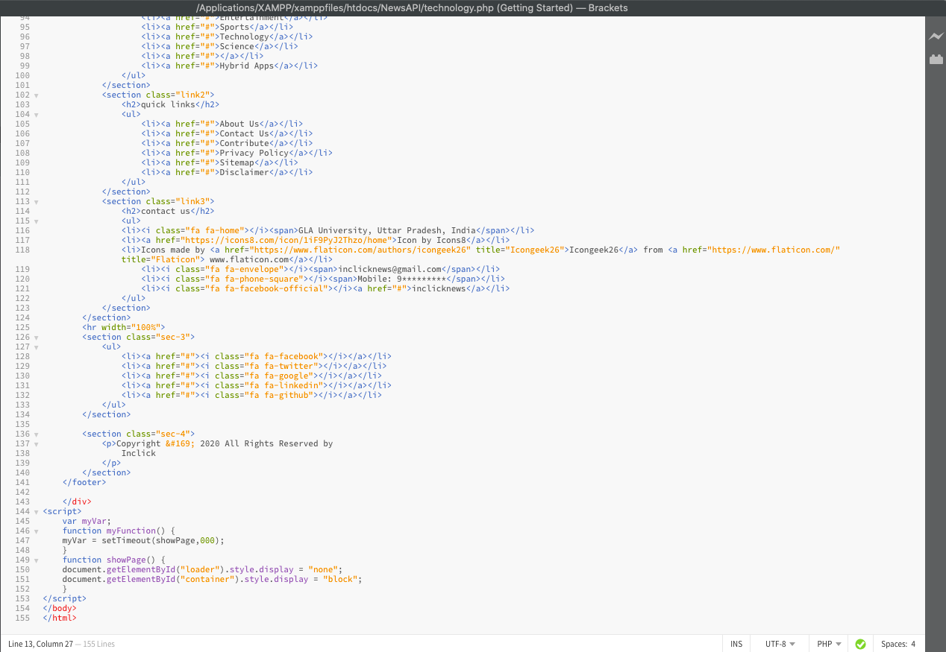

(Footer)

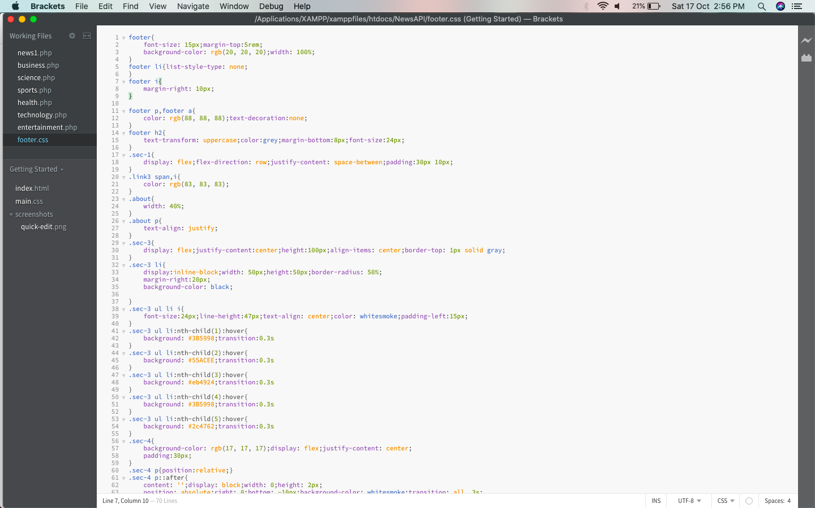

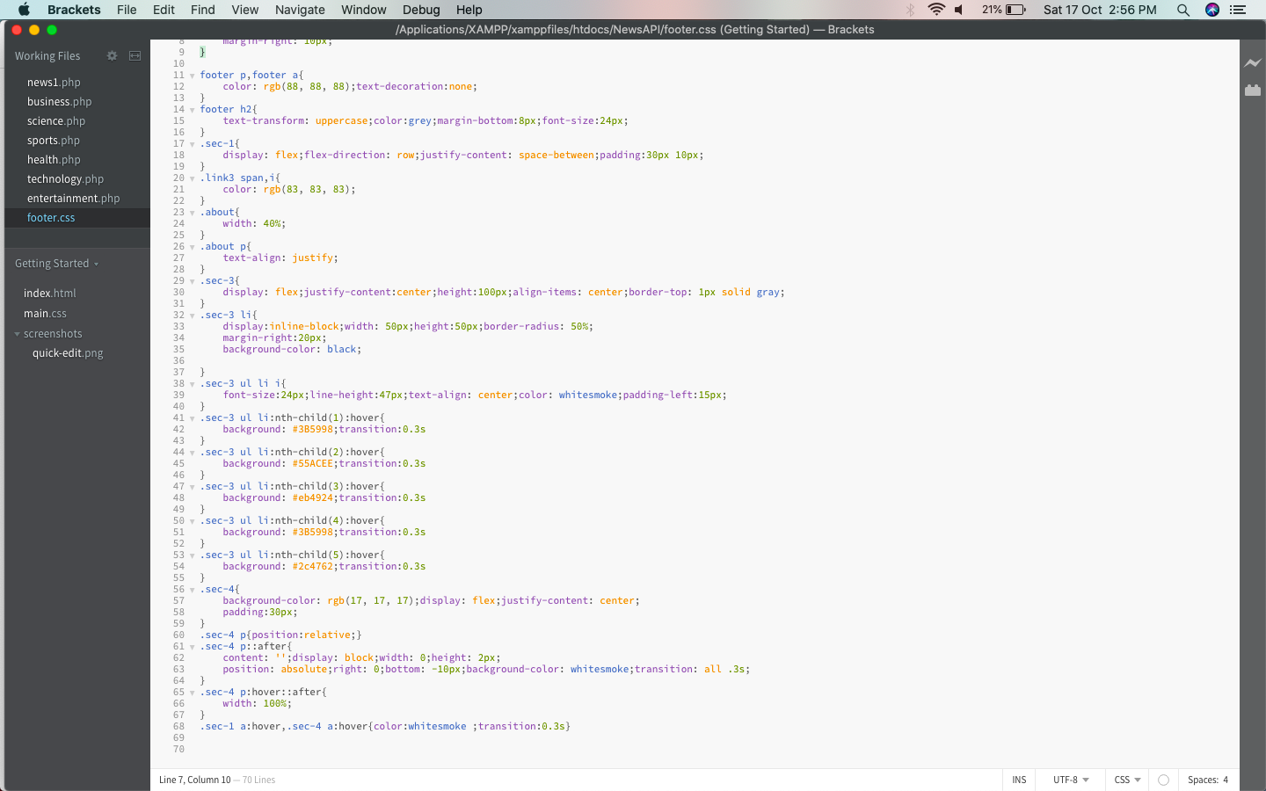

(Header)

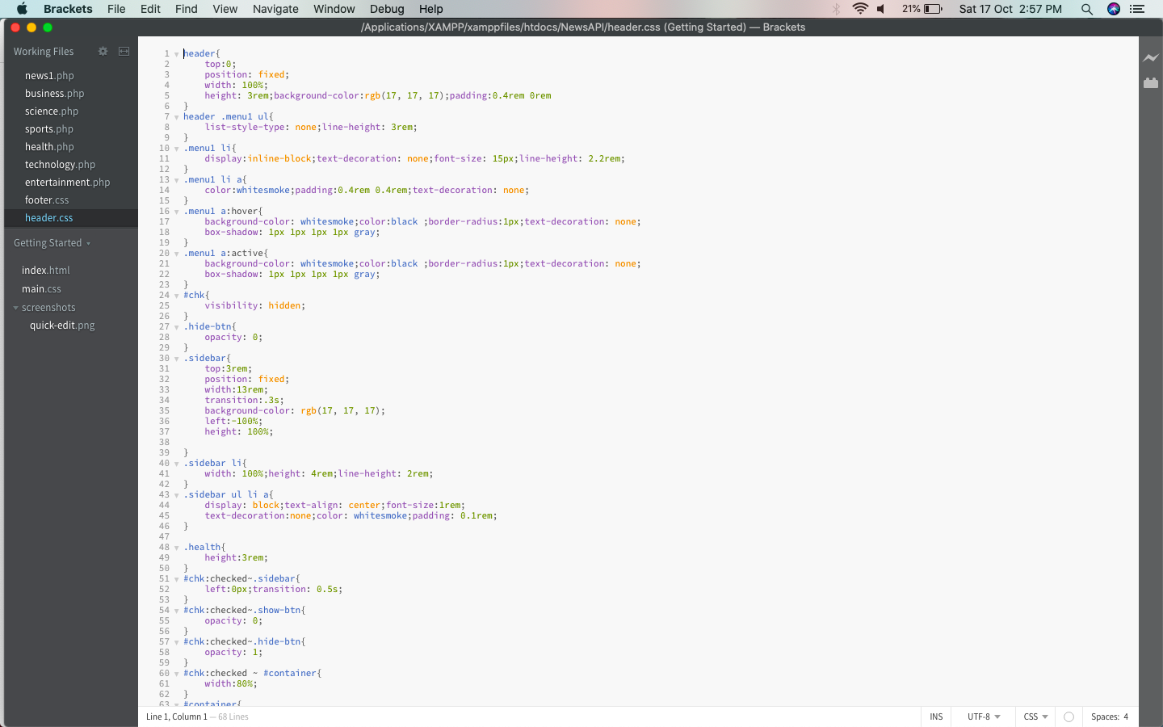

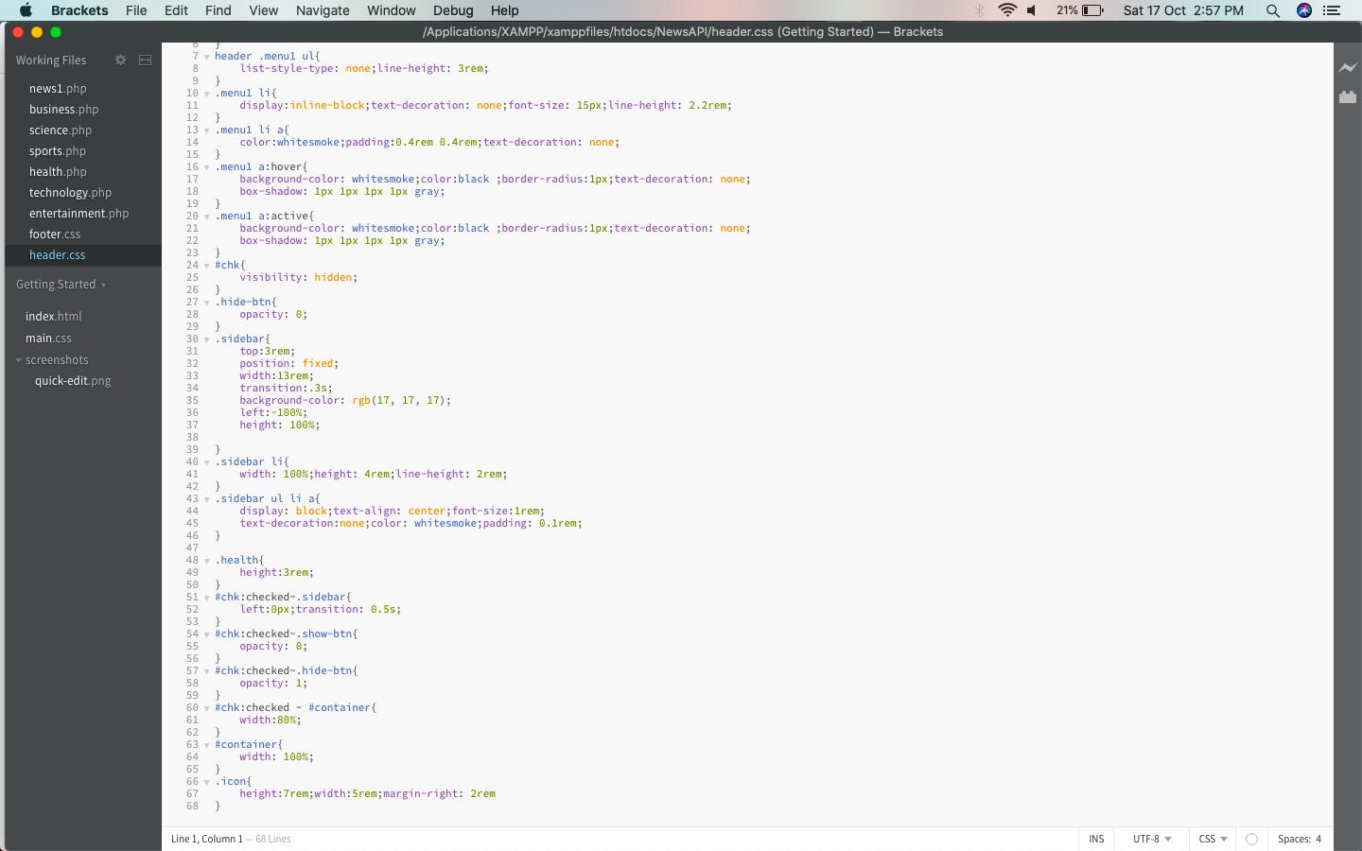

(Style.css)

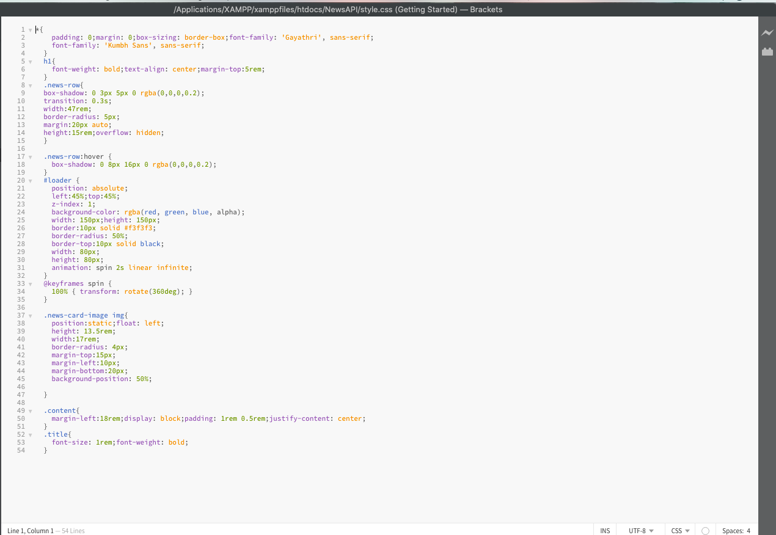

**References**

• https://newsapi.org/

• https://www.geeksforgeeks.org/fetching-top-news-using-news-api/